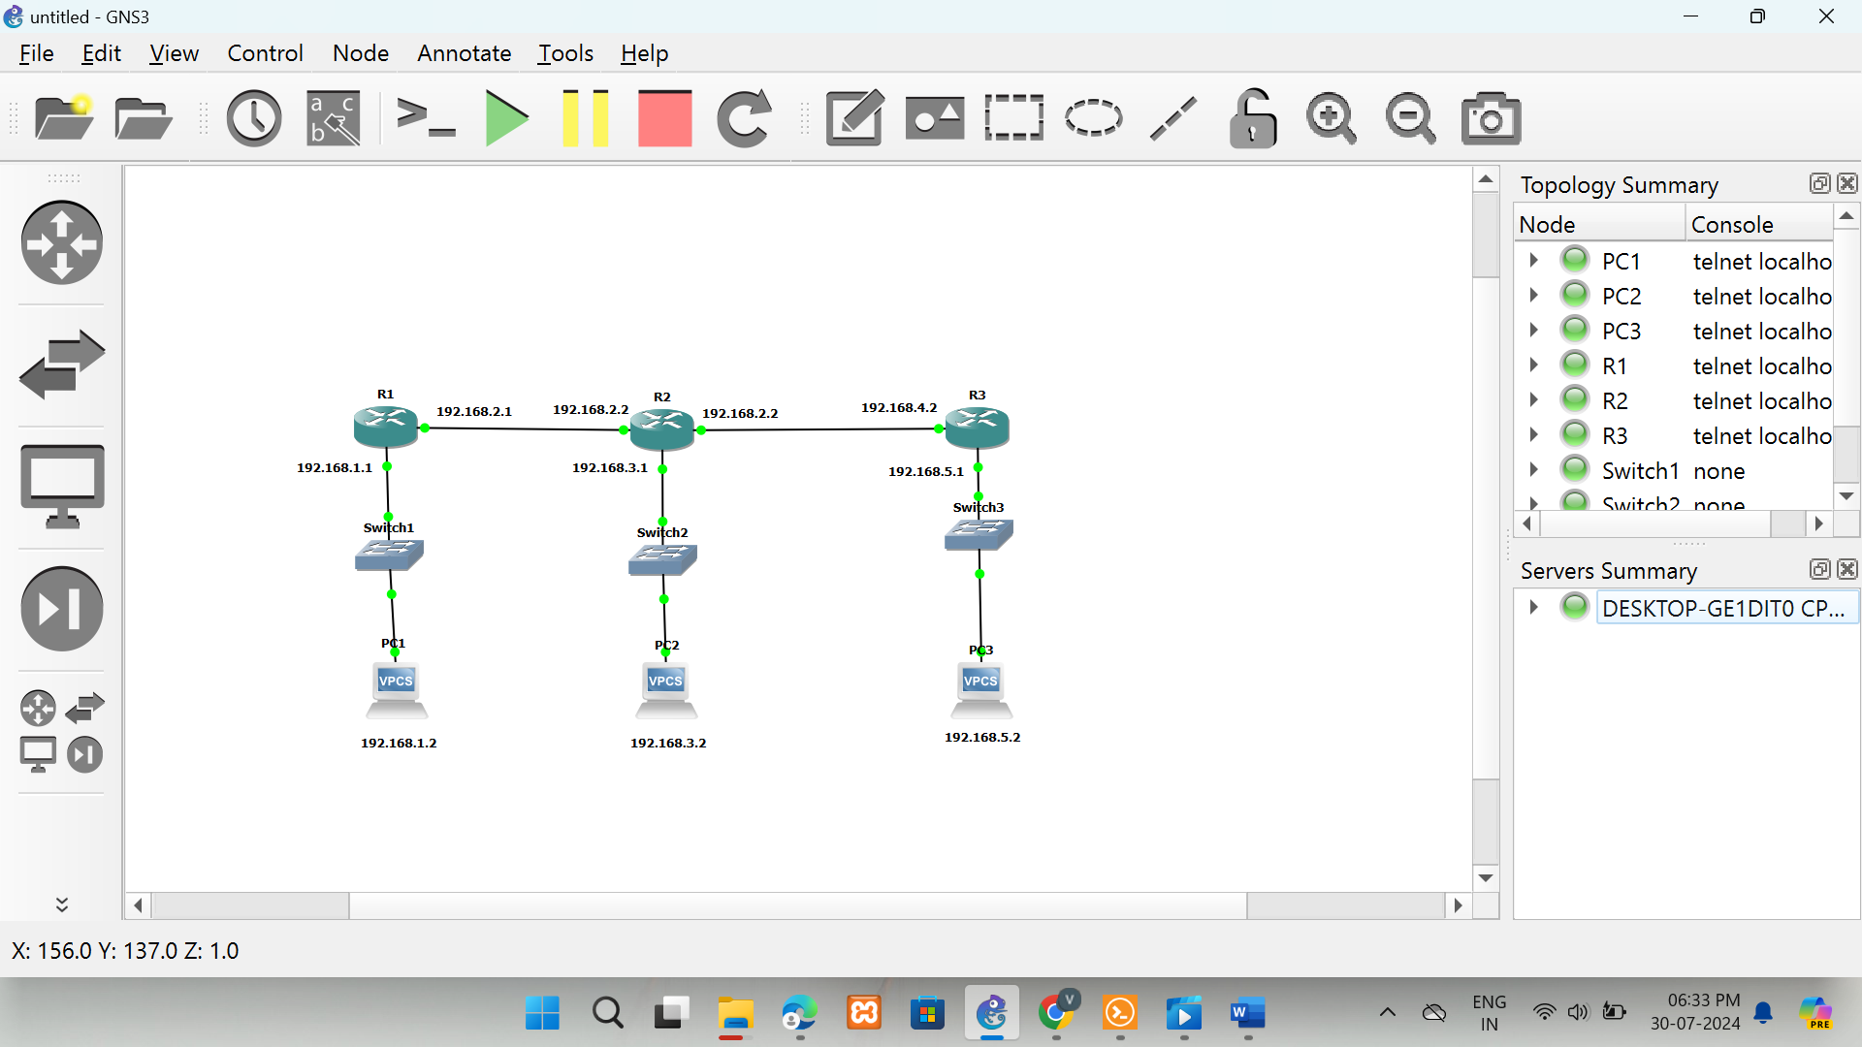

PC1

Ip 192.168.1.2/24 192.168.1.1

PC2

Ip 192.168.3.2/24 192.168.3.1

PC2

Ip 192.168.5.2/24 192.168.5.1

**Router 1**

**R1**

configure terminal

Interface fa0/0

Ip address 192.168.1.1 255.255.255.0

no shutdown

exit

Interface fa1/0

Ip address 192.168.2.1 255.255.255.0

no shutdown

exit

**R2**

configure terminal

Interface fa0/0

Ip address 192.168.3.1 255.255.255.0

no shutdown

exit

Interface fa1/0

Ip address 192.168.2.2 255.255.255.0

no shutdown

exit

Interface g2/0

Ip address 192.168.4.1 255.255.255.0

**R3**

configure terminal

Interface g2/0

Ip address 192.168.4.2 255.255.255.0

no shutdown

exit

Interface fa0/0

Ip address 192.168.5.1 255.255.255.0

no shut

exit

**Configure rip version1**

**R1**

configure terminal

router rip

version 1

network 192.168.1.0

network 192.168.2.0

exit

**R2**

configure terminal

router rip

version 1

network 192.168.2.0

network 192.168.3.0

network 192.168.4.0

exit

exit

**R3**

configure terminal

router rip

version 1

network 192.168.1.0

network 192.168.2.0

exit